INCOME INEQUALITY AND CONCENTRATION OF WEALTH

I could never have imagined that a protest speech, no matter how strong the message, would lead to a crowd of people marching to the capital building where people would break through doors and expect that no one would get shot. It is hard to believe. Before that, how could George Floyd's death, as horrific as it was, trigger such widespread protest to the point of attacking police, burning buildings, toppling statues, and looting?

There are many factors involved especially the Covid lock-down factor but I would like to point out another important factor for your consideration, the economic squeeze that has been building up for the past 50 years. Most people have no understanding of the intricate mechanisms involved but younger generations know intuitively that something is definitely wrong. They are not getting ahead and at the same time they are told that this is the richest country in the world. The incredible advances in technology should have resulted in younger generations having a higher standard of living than their parents but now, the opposite is true. On top of that, technology has gotten to the point that college education is almost essential but at the same time it has been made unaffordable. I think that a big part of what we are seeing is the venting of this frustration.

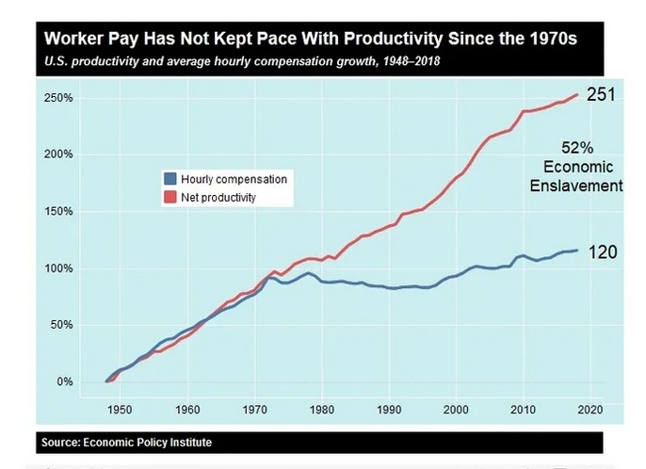

(5)

Income inequality was not always such a problem. This chart is the key. It shows hourly productivity steadily increasing at the same rate as hourly compensation for the average worker from 1946 until about 1971 which is how a natural economy functions, fair and balanced. Actually, real family income roughly doubled from the late 1940s to the early 1970s for all income levels, rich, middle class, and poor.(35)

"In the 1950s and 1960s homelessness declined to the point that researchers were predicting its virtual disappearance in the 1970s.” Since then homelessness has grown to crisis levels. Why? (38) The Civil Rights Act, the Voting Rights Act, and the Fair Housing Act were passed in the 60s. With all of that progress toward racial equality, in the 70s “blacks, as well as whites, improved their socioeconomic status. Among both races, educational attainment increased, the occupational distribution was upgraded, and real purchasing power rose markedly. In almost every comparison, the gains were somewhat greater among blacks than among whites and thus most indicators of racial differentiation declined.” (34)

In the 1960s letters were written with typewriters, copies were done with carbon paper, corrections were done with whiteout, and mechanical drawings were done with pencil on vellum paper. The most popular electronic device at that time was a 6 transistor AM radio. Of course, since then advanced technology has resulted in sophisticated tools with a huge increase in productivity and the corresponding wealth produced. But after 1971 something dramatically changed. Advancing technology resulted in productivity increasing 150% but wages, adjusted for inflation, only increased 50%. The increased wealth in that was produced after 1971 did not result in a proportional increase in average worker compensation.

The average workers are getting paid half of what they would be getting if a natural economy had continued from 1970. With a perverted economy instead, what evolved was economic enslavement at a level of at least 50%. Do not complain to your boss, with unfair foreign competition he is in the same boat.

If you are not getting ahead and you are white you are told that it is your fault. Work harder! If you are not white, then the problem is systemic racism and white privilege. What is systemic is the high level of economic enslavement that is so sophisticated that people can be told the lie that they live in a free country and still believe it. The reality is WE DO NOT LIVE IN A FREE COUNTRY!
RELATIVE GROWTH OF AFTER TAX AND TRANSFER INCOME-WEALTH

(4) This chart shows where a lot of the wealth from economic oppression has gone. The rich have had dramatic growth in income and wealth. This chart does not show that all incomes were equal in 1970, they were not, but whatever level that was for each group was used as a reference. This chart shows the dramatic increase in income growth for the top 1% even after the 2008 crash.

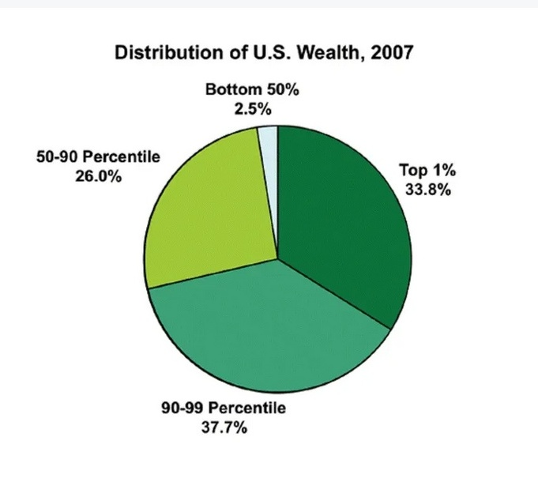

(2)

This chart is from 2007 concerning wealth inequality. It shows that the bottom 50% had 2.5% of the wealth. The top 10% of families (the portion on the right plus the portion at the bottom) had over 70% of the wealth. This was before the 2008 crash, it has gotten even worse. In 2019 the bottom 50% had less than 1% of the wealth! (3)
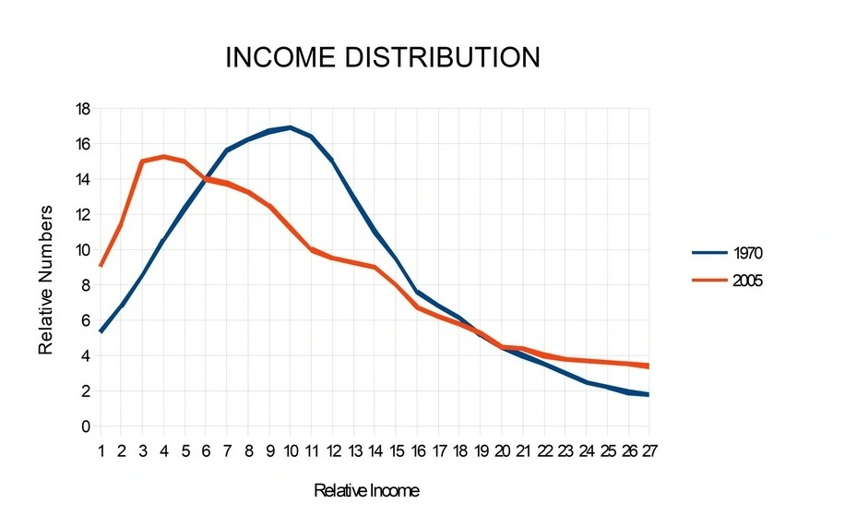
(6)

This chart is from the Statistical Abstracts of the United States income tax data. I plotted the income distribution for years 1970 and 2005. In 1970 we see a bell curve showing a normal, natural, distribution. It shows a majority in the middle class with fewer and fewer as incomes increase and fewer and fewer as incomes decrease. But in the year 2005 we see a distorted, unnatural distribution, the middle class has completely disappeared and the peak income is near the poverty level. This was the case even before the 2008 crash! For 2016 the distortion was even worse.
Since 1971, the perverted economy pushed the middle class toward the poverty level while the poor minorities at the poverty level were made even poorer requiring more government assistance. Even though economic enslavement has been a slow process taking over 50 years, people intuitively know that something is very wrong and feel that they deserve more. This produced an entitlement mentality that has resulted in the dramatic growth in Welfare, Medicare, Social Security and other entitlement programs which have already made this country a semi-socialist country. Social programs are a method for politicians to buy votes from the struggling masses. The bigger the struggle, the more votes.
Credit cards have an appeal to the entitlement mentality created by economic enslavement, a way to get ahead and worry about the consequences later. Credit card debt has also grown exponentially and greatly increases the level of economic struggle.
Cultural differences play a role in economic outcome. Asians earn 30% more than the average white person. Is this a sign of systemic racism? Do employers discriminate against Whites in favor of Asians or is something else going on? Could it be that emphasis on education is part of the Asian culture? Of course. (60)

Barack Obama acknowledged this problem with the Black culture: "children can’t achieve unless we raise their expectations and turn off the television sets and eradicate the slander that says a Black youth with a book is acting White." (61) According to Education Week, "Emphasizing Sports Over Academics Sets Up Black Boys to Lose." (62)
Crime is a way poor minorities adapt to the economic squeeze which results in racial disparities in policing, incarceration, and the lack of employment opportunities when released. That made it easy for some to gather statistics from poor minority areas and claim “Systemic Racism.” This recent media narrative has been very successful in inciting violent riots and promoting the “de-fund the police” insanity.

Without economic oppression, income levels would have increased and crime would have decreased especially in minority neighborhoods. During the Trump economic boom from 2018 to 2019, which resulted in the lowest black unemployment level in history but only a 10% increase in average household income, 29% fewer black persons and 22% fewer white persons were victims of serious crimes. (43,52) Imagine what 100% increase in average income would have done.
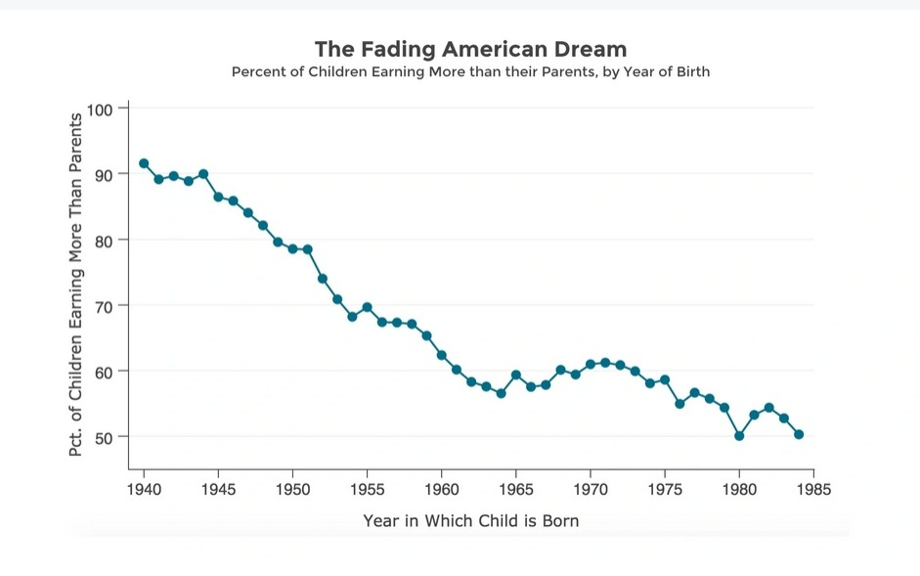
(11)

One would expect, as technology advances the result is increased worker productivity and a steadily increasing standard of living. Until recently each generation did have a higher standard of living than their parents. However, it has now gotten to the point that most children will actually have a lower standard of living than their parents.

The establishment has such control of the economy that they can determine what level of standard of living they will allow the average person to have. I think that they went way too far.

You can see that this is a very serious problem. “Tax the rich” is a common response. Unfortunately that would not address the cause at all. There will always be rich people due to a combination of skill and luck or quite often being able to take advantage of the power of government to take money away from us and give it to them. (Hence the term “lucrative government contract.”)
Over the years politicians have offered many social programs to reduce the level of enslavement in exchange for votes, Social Security, Welfare, Food Stamps, School Lunch, etc. Present Democratic proposals are free college, medicare for all, and universal child care (free babysitting). This does nothing to solve the fundamental problem. It will actually increase government's power and control over all of us.
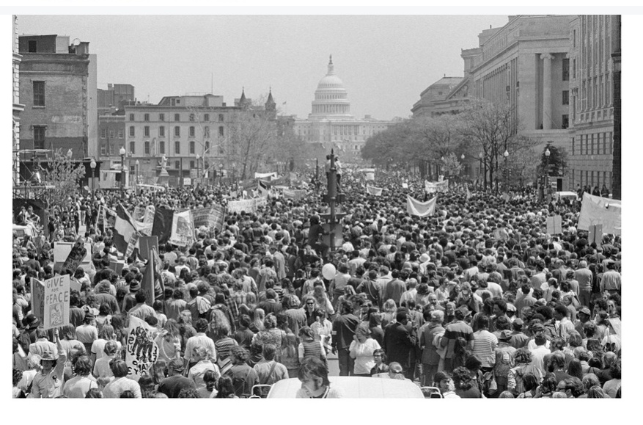
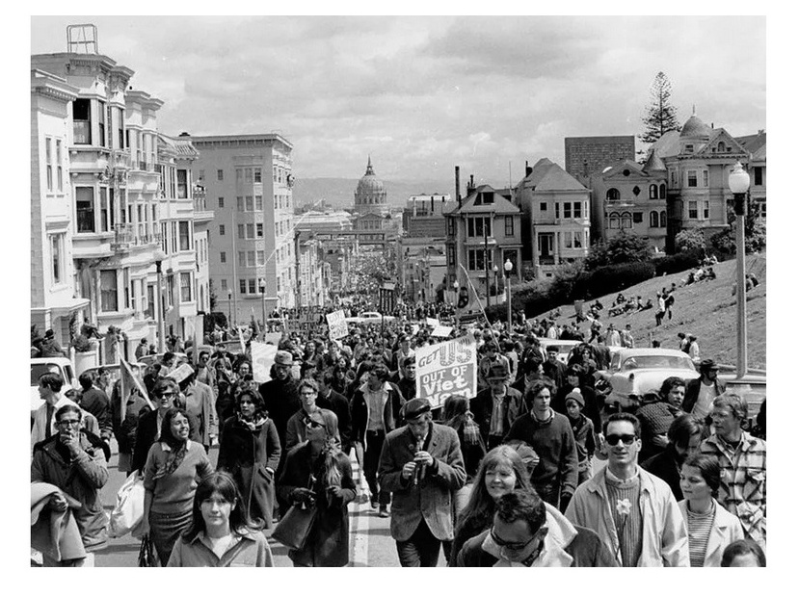
(37)

The late 60s and early 70s anti-establishment revolution had everything to do with it. There were many demonstrations but on November 15, 1969, over 500,000 people marched through Washington, D.C. protesting the Vietnam War and the draft.(7) That accomplishment was beyond incredible, it was a miracle considering that there was no internet and no cell phones at that time. The establishment took notice and took swift action against the young and arrogant that had way too much free time and had the audacity to protest the war and the draft. The Aerospace Cutback in 1971 provided the loss hundreds of thousands of jobs which resulted in reduced wages in order to increase the level of struggle that has been the case sense. Mass protests against the war gradually disappeared.
The establishment also easily eliminated the draft as military service then became the best option for employment for many young people.

I was 25 years old at that time and remember how the Aerospace Cutback caused a sudden and drastic change in the economy. Before the cutback jobs were plentiful and wages were great. I could work for 4 or 5 months, quit my job, have plenty of money to take off a month or two and not worry about being able to find another job. After the cutback I felt lucky to get a job and I kept it despite the lower wages. It is now labeled the Aerospace Recession to give the illusion that it was a natural economic event. It definitely was not.

Another thing that I remember in the 1970s was the massive imports of Japanese cars that were actually higher quality than American cars. My first Honda Civic went 167,000 miles, which was much more than the average American car at that time.

With low tariffs and high corporate taxes, domestic automobile production could not compete resulting in bankruptcy and government bailouts starting in 2008. The change to a perverted and unethical economy has mainly involved the following:

1) THE AEROSPACE CUTBACK provided a sudden loss of jobs.
2) INFLATION, which causes prices to steadily rise relative to wages,
3) ANTI-AMERICAN GLOBALIZATION by increasing personal and corporate taxes
and lowering tariffs,
4) REGULATIONS, which are an additional burdensome increase the cost of doing business.
5) FOREIGN AID which directly benefits foreign countries and has a negative
effect on our economy.

A thorough understanding of the above problems can result in effective SOLUTIONS.

